**Spark Setup with IntelliJ Idea**

1. Download and install IntelliJ Idea from below location <https://www.jetbrains.com/idea/download/#section=windows>
2. Download and install java from below location. <http://www.oracle.com/technetwork/java/javase/downloads/jdk10-downloads-4416644.html>

Set the environment variables for Java as below

* 1. Go to Environment Settings

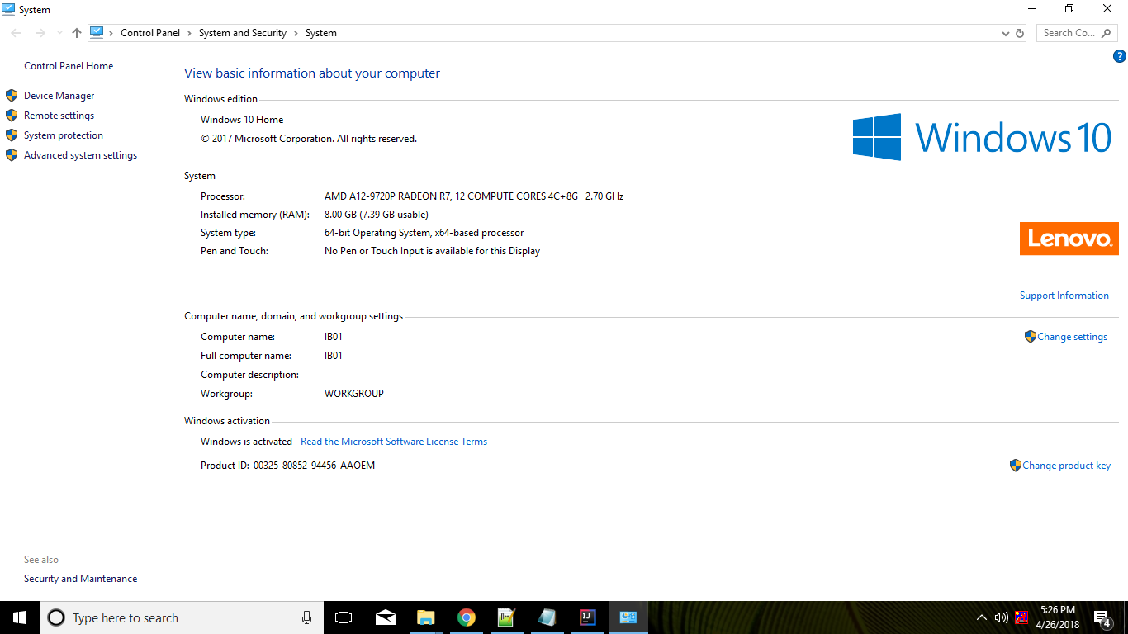

* 1. Click on “Environment Settings” in above window

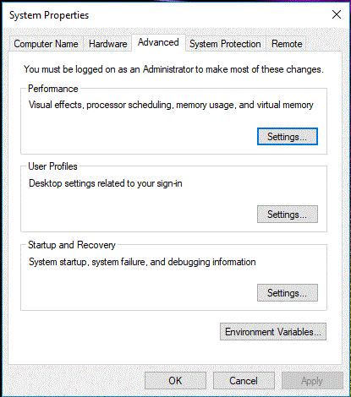

* 1. Click on Environment Variables button above

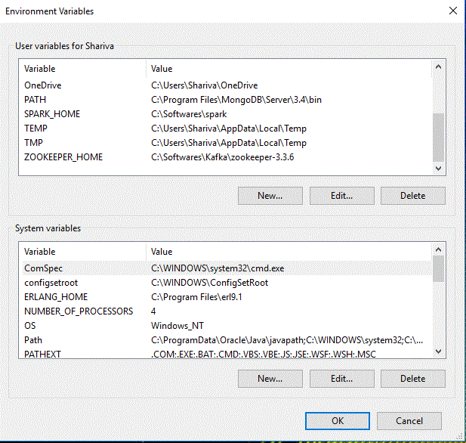

* 1. Click on New button under User variables section and enter below entries for java.

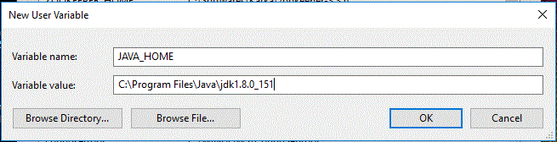

* 1. Now select path and click on Edit under System variables section.

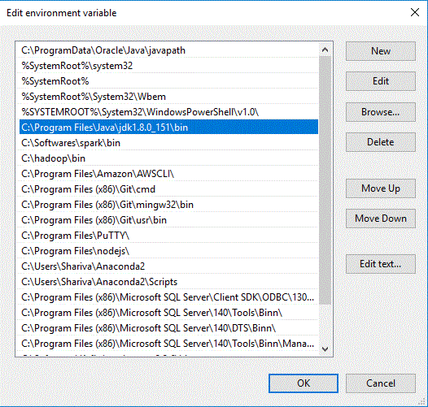

* 1. Enter the highlighted value above by clicking on “New” button and selecting java/bin path.

1. Download spark from below location

<https://spark.apache.org/downloads.html>

1. Set the environment variable for Spark home as we set for Java above.
2. Now open IntelliJ Idea.

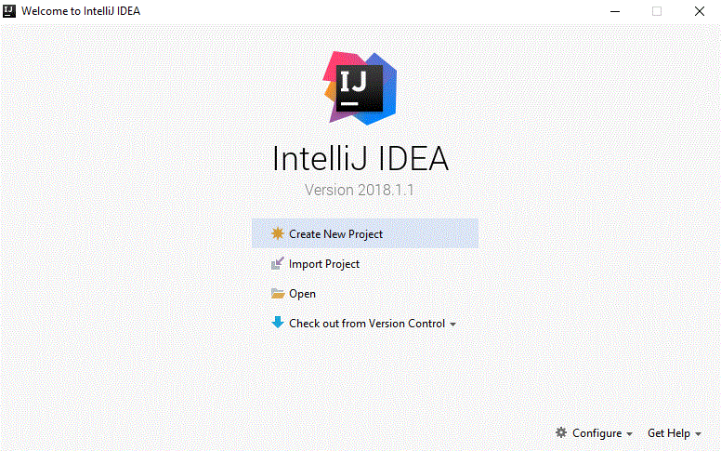

1. Click on Configure and select plugin from the dropdown menu.

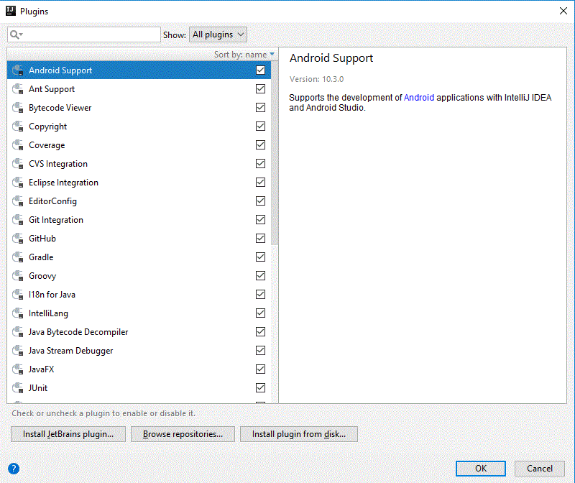

1. Search for scala and click on install button on right pane

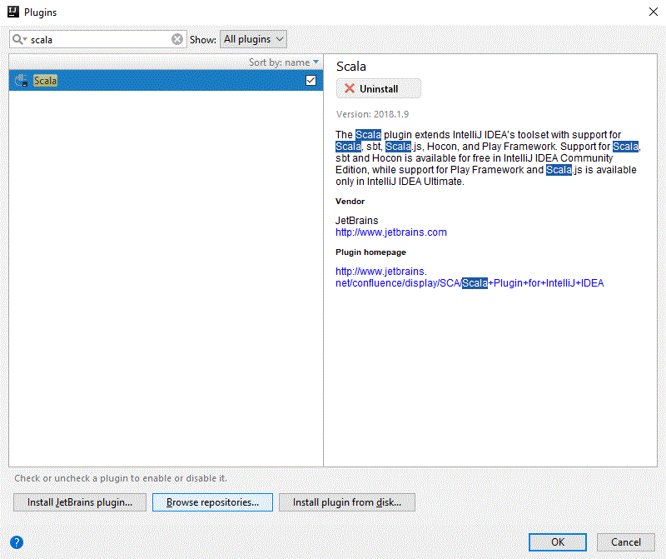

1. Now click on “Create New project”in IntelliJ window

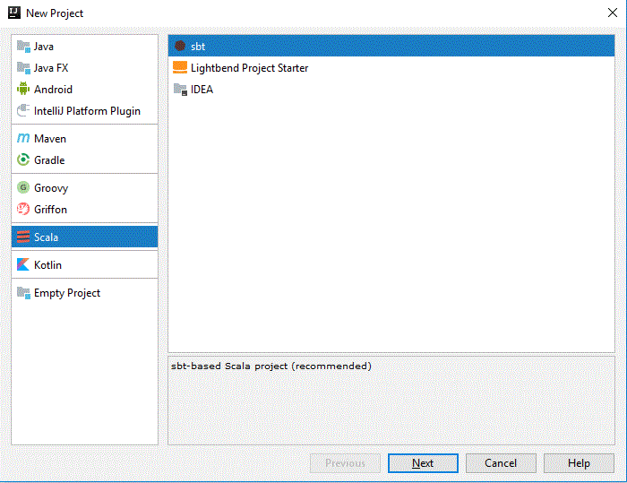

1. Select “Maven” option and click on Next

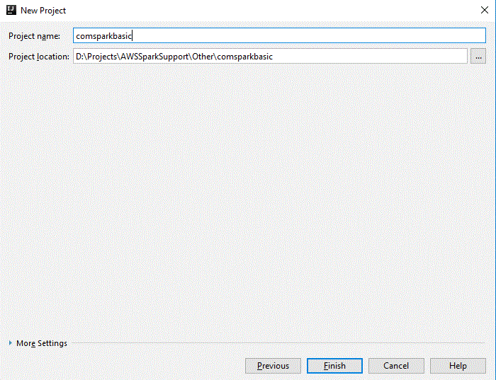

1. Click on Finish.

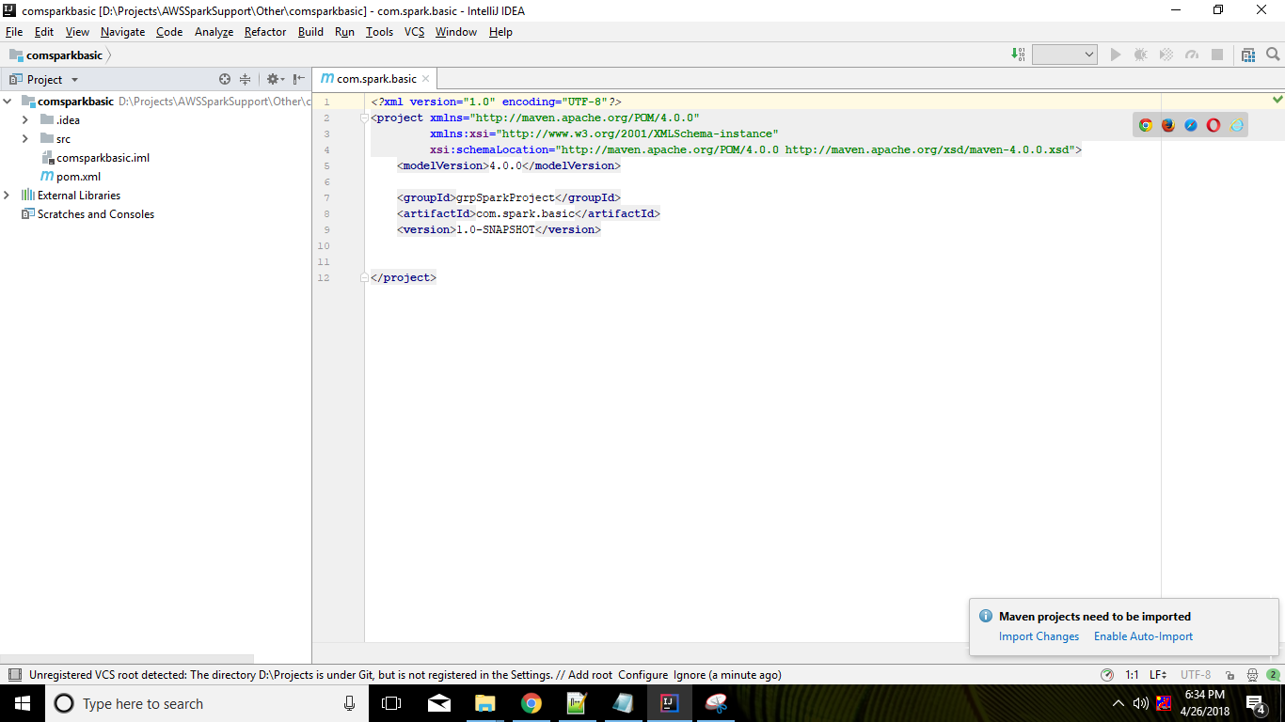

1. Click on Enable Auto import.
2. Expand SRC and you will get the Java folder added after doing setup. For adding scala support right click on project and select “Add Framework Support”

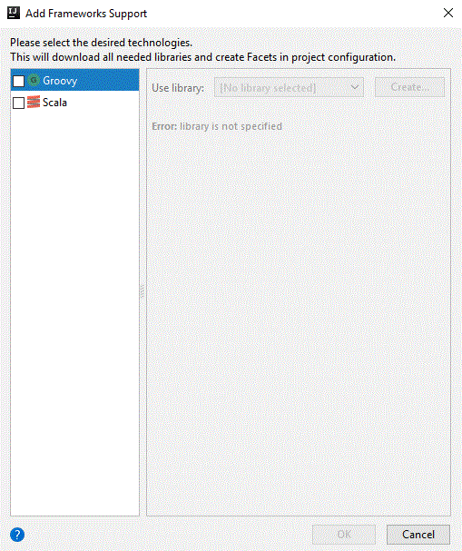

1. Select “Scala” checkbox and click on OK. you can see the scala nature added as below

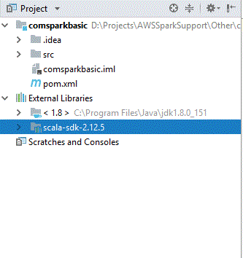

1. Now we can add new folder under SRC and rename it as “Scala”
2. Right click on “Scala” folder. Goto “Mark directory as” -> “Sources Root”
3. Open pom.xml file and add below dependencies

